Design Thinking

|  |  |
| --- | --- |
| DATE | 28-09-2023 |
| TEAM ID | PROJ-212172_TEAM_I |
| PROJECT NAME | Earthquake Prediction Model using PYTHON |
| MAXIMUM MARK |  |

What are the 5 Stages of the Design Thinking Process

The five stages of design thinking process are:

Empathize:

research your users' needs.

Define:

state your users' needs and problems

Ideate:

challenge assumptions and create ideas.

Prototype:

start to create solutions.

Test:

try your solutions out.

Let’s dive into each stage of the design thinking process.

**Stage 1: Empathize—Research Your Users' Needs**

The first stage of the design thinking process focuses on **user-centric research**. You want to gain an empathic understanding of the problem you are trying to solve. Consult experts to find out more about the area of concern and conduct observations to engage and empathize with your users.

You may also want to immerse yourself in your users’ physical environment to gain a deeper, personal understanding of the issues involved—as well as their experiences and motivations. Empathy is crucial to problem solving and a human-centered design process as it allows design thinkers to set aside their own assumptions about the world and gain real insight into users and their needs.

Depending on time constraints, you will gather a substantial amount of information to use during the next stage

The main aim of the Empathize stage is to develop the best possible understanding of your users, their needs and the problems that underlie the development of the product or service you want to create

### Stage 2: Define—State Your Users' Needs and Problems

In the Define stage, you will organize the information you have gathered during the Empathize stage. You’ll analyze your observations to define the core problems you and your team have identified up to this point.Defining the problem**and problem statement must be done in a human-centered manner**.

The Define stage will help the design team collect great ideas to establish features, functions and other elements to solve the problem at hand—or, at the very least, allow real users to resolve issues themselves with minimal difficulty. In this stage, you will start to progress to the third stage, the ideation phase, where you ask questions to help you look for solutions

Seismology continues to face considerable difficulties in predicting earthquakes, despite its critical importance for human security. Several studies argue that an earthquake forecast must include the following;

1. A specified area or location

2. A precise period,

3. A defined magnitude range

4. An exact probability of occurrence

In other words, a prediction of an earthquake must include the time, location, magnitude, probability, and reason for its occurrence. The purpose of earthquake forecasts is to aid disaster control organizations in preparing for earthquakes.

When a powerful earthquake is forecast, disaster control administrators must be alerted to take precautionary measures. In catastrophe preparedness, decisions and activities are centered on preventing losses. Conspicuously, a variety of earthquake prediction techniques have been implemented to reduce damage.

### Stage 3: Ideate—Challenge Assumptions and Create Ideas

Ideate: the third phase of design thinking, where you identify innovative solutions to the problem statement you’ve created.

During the third stage of the design thinking process, designers are ready to generate ideas. You’ve grown to understand your users and their needs in the Empathize stage, and you’ve analyzed your observations in the Define stage to create a user centric problem statement. With this solid background, you and your team members can start to **look at the problem from different perspectives and ideate innovative solutions to your problem statement**.

There are hundreds of ideation techniques you can use—such as Brainstorm, Brainwrite worst possible idea and scamper. Brainstorm and Worst Possible Idea techniques are typically used at the start of the ideation stage to stimulate free thinking and expand the problem space.

This allows you to generate as many ideas as possible at the start of ideation. You should pick other ideation techniques towards the end of this stage to help you investigate and test your ideas, and choose the best ones to move forward with—either because they seem to solve the problem or provide the elements required to circumvent it.

1. Presenting a comprehensive earthquake prediction framework using sophisticated IoTedge–cloud computing platforms to extract optimum features from complicated data.

2. Analyzing IoT data and events from IoT sensors and extending to the distant cloud platform, to enhance the data gathering and analysis processes

3. Developing a prototype architecture to collect real-time IoT data for effective prediction systems.

4. Evaluating the proposed model for performance assessment in terms of several metrics including classification efficacy, prediction efficiency, computational delay, reliability, and stability.

### Stage 4: Prototype—Start to Create Solutions

Prototype: the fourth phase of design thinking, where you identify the best possible solution.

The design team will now produce a number of inexpensive, scaled down versions of the product (or specific features found within the product) to investigate the key solutions generated in the ideation phase. These prototypes can be shared and tested within the team itself, in other departments or on a small group of people outside the design team.

This is an experimental phase, and the aim is to **identify the best possible solution for each of the problems identified during the first three stages**. The solutions are implemented within the prototypes and, one by one, they are investigated and then accepted, improved or rejected based on the users’ experiences.

By the end of the Prototype stage, the design team will have a better idea of the product’s limitations and the problems it faces. They’ll also have a clearer view of how real users would behave, think and feel when they interact with the end product.

We will use four models in this project:

1) Linear regression

2) Support vector machine

3) NaiveBayes

4) Random forest

**Linear Regression**

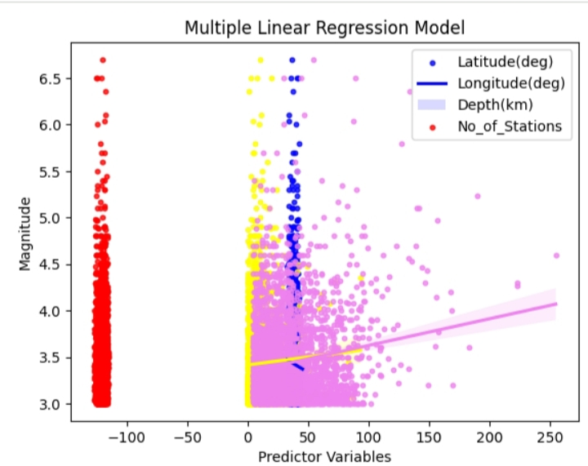

Linear regression is a type of supervised machine learning algorithm that is used to model the linear relationship between a dependent variable (in this case, earthquake magnitude) and one or more independent variables (in this case, latitude, longitude, depth, and the number of seismic stations that recorded the earthquake).

In this situation, we have used multiple linear regression to model the relationship between earthquake magnitude and latitude, longitude, depth, and the number of seismic stations that recorded the earthquake

. Magnitude = -0.6028 * Latitude + 1.2012 * Longitude - 0.0008 * Depth + 0.0239 * No_of_stations + 0.1573

The results we obtained from the linear regression model were as follows:

● Mean squared error (MSE): 0.17562

● R-squared (R2) score: 0.03498

**SVM**

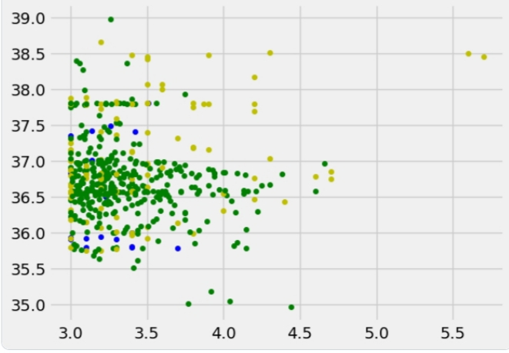

Once the SVM model has been trained on the data, it can be used to predict the magnitude of a new earthquake given its features (latitude, longitude, depth, and number of seismic stations). This can be useful for predicting the magnitude of earthquakes in real-time and for better understanding the factors that contribute to earthquake occurrence

. The predicted values from SVM model when evaluated using mse and r2 metrics:

● Mean squared error (MSE): 0.53166

● R-squared (R2) score: -1.92129

**Naive Bayes**

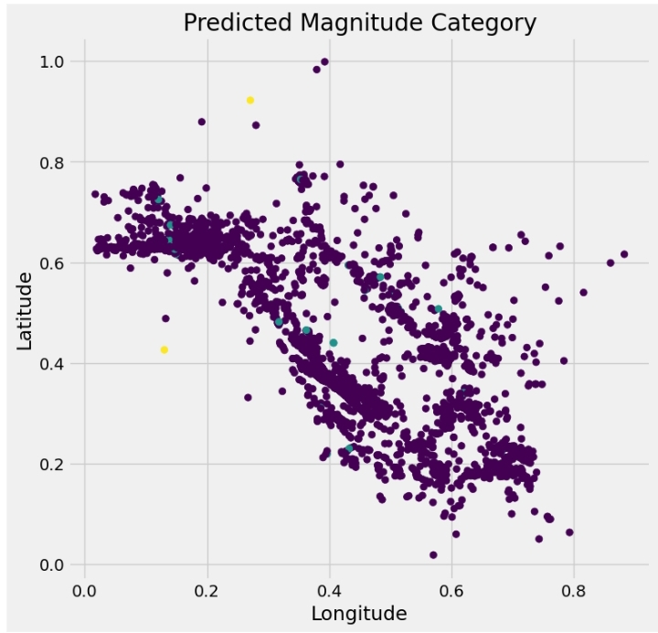

Naive Bayes classifier to predict the magnitude of earthquakes b6ased on their latitude, longitude and number of monitoring stations.

● Accuracy: 0.9853947125161767

● Confusion Matrix: [[5327 35 1] [ 38 3 1] [ 4 0 0]]

**Random Forest**

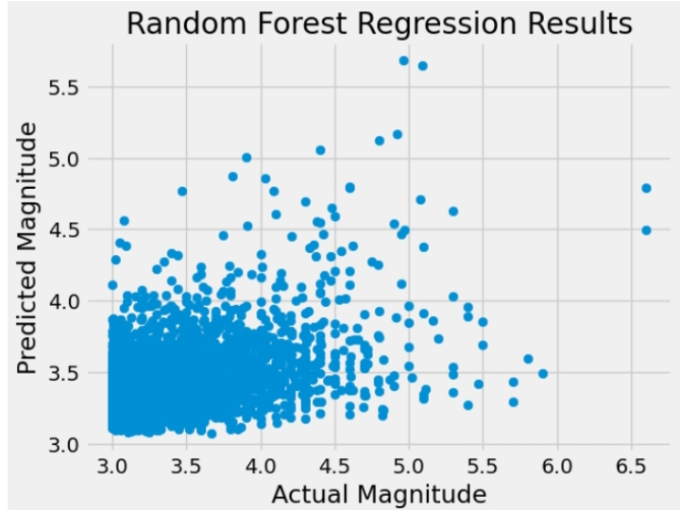

we used the random forest algorithm to predict the magnitude of earthquakes based on their latitude, longitude, depth, and number of monitoring stations The results we obtained from the random forest model were as follows:

● Mean squared error (MSE): 0.15599

● R-squared (R2) score: 0.14288 Stage 4:

Prototype—Start to Create Solutions

Prototype: the fourth phase of design thinking, where you identify the best possible solution.

The results from the models indicate that the random forest model was able to accurately predict the magnitude of earthquakes based on the given features. The low MSE and high R2 score indicate that the model was making accurate predictions, and was able to explain a large proportion of the variance in the target variable.

Overall, the random forest algorithm is a powerful tool for machine learning tasks, and can be used in a variety of applications, including finance, healthcare, and image recognition

### Stage 5: Test—Try Your Solutions Out

Test: the fifth and final phase of the design thinking process, where you test solutions to derive a deep understanding of the product and its users.

Designers or evaluators rigorously test the complete product using the best solutions identified in the Prototype stage. This is the final stage of the five-stage model; however, in an iterative process such as design thinking, the results generated are often used to redefine one or more further problems. This increased level of understanding may help you investigate the conditions of use and how people think, behave and feel towards the product, and even lead you to loop back to a previous stage in the design thinking process. You can then proceed with further iterations and make alterations and refinements to rule out alternative solutions. **The ultimate goal is to get as deep an understanding of the product and its users as possible.**